DocRestore: Deep Learning-Based Document Image Restoration

Cover Information
Team ID: 15
Project Title: DocRestore: Document Image Restoration for OCR Readability
Team Members:
Name | SJSU ID | Email
FNU Shamathmika | 018326464 | shamathmika.shamathmika@sjsu.edu
Apoorva Adimulam | 018216770 | apoorva.adimulam@sjsu.edu
Sakshat Patil | 018318287 | sakshat.patil@sjsu.edu
Project Track: Modern Deep Learning Pipeline (Training + Deployment)
Focused Areas: Computer Vision, Image Restoration, Document Understanding, Deep Learning

Abstract
Document images captured via scanning or photocopying often suffer from degradation artifacts such as ink bleed, stains, wrinkles, fold marks, and compression noise, which significantly impair both human readability and automated OCR accuracy. This project presents DocRestore, a deep learning system that restores degraded document images to clean, high-contrast, machine-readable versions. We implement and compare two state-of-the-art image restoration architectures: DocRes (U-Net with multi-head attention bottleneck) and NAFNet (Nonlinear Activation Free Network). Both models are trained on a synthetically degraded dataset of approximately 1790 document image pairs generated from 99 arXiv papers using the Augraphy degradation pipeline. We evaluate both models on PSNR, SSIM, and OCR Character Error Rate (CER). DocRes achieves 24.11 dB PSNR and 0.8993 SSIM on the test set, while NAFNet achieves 20.70 dB PSNR and 0.8763 SSIM, both representing substantial improvements over the unrestored baseline (14.19 dB PSNR, 0.7738 SSIM). The system is deployable as an interactive Gradio web application supporting real-time inference.

1. Introduction and Problem Description

What problem are we solving?
Digitized documents such as scanned books, photocopied records, archival materials, receipts, and printed forms routinely suffer from a wide range of degradation artifacts that compromise both visual quality and machine readability. These artifacts include:
- Ink bleed and bleed-through: Ink seeping through or between paper layers
- Stains and discoloration: Coffee stains, yellowing, and paper aging
- Physical deformations: Folds, wrinkles, and torn edges
- Photocopy and scan artifacts: Uneven illumination, dirty drum marks, JPEG compression
- Periodic noise: Halftone patterns and scanner line artifacts
These degradations are particularly problematic for downstream tasks such as Optical Character Recognition (OCR), document indexing, and information extraction, where even mild corruption can cause significant character-level errors. Current OCR systems such as Tesseract perform well on clean documents but degrade sharply on corrupted inputs.

Why is it important?
The digitization of documents is a cornerstone of modern archival, legal, medical, and administrative workflows. Libraries, government agencies, hospitals, and businesses process millions of scanned documents daily. A reliable preprocessing step that restores degraded images before OCR can meaningfully reduce manual verification overhead and improve the accuracy of downstream information retrieval pipelines. As large language models increasingly consume document-derived data, the quality of upstream OCR feeds directly into knowledge quality.

Target users and application scenarios
- Archivists and librarians digitizing historical documents
- Enterprise document management systems processing scanned invoices, forms, and contracts
- Legal and medical records digitization workflows
- Researchers preprocessing noisy scanned papers for analysis

2. Background and Related Work

Document image restoration
Document image enhancement has a long history, spanning classical binarization (Otsu thresholding, Sauvola method) and denoising (wavelet shrinkage, BM3D). Modern deep learning approaches have surpassed classical methods on nearly every benchmark. Relevant prior work includes:
- DocRes (Zhang et al., CVPR 2024): A unified U-Net-style architecture for multi-task document restoration using adaptive inference. We adopt their architecture design as our primary model.
- NAFNet (Chen et al., ECCV 2022): "Simple Baselines for Image Restoration" introduces a nonlinear-activation-free encoder-decoder that achieves state-of-the-art results on image deblurring and denoising benchmarks by replacing ReLU with a channel-wise SimpleGate mechanism.
- Augraphy (Socie et al., 2022): A Python library for realistic synthetic document degradation, covering ink, paper, and post-processing artifact stages. Used as our data augmentation engine.
- U-Net (Ronneberger et al., MICCAI 2015): The foundational skip-connection encoder-decoder architecture underpinning DocRes.
- Perceptual Loss (Johnson et al., ECCV 2016): VGG-based feature matching loss for texture-preserving image synthesis.

Datasets
We generate our own synthetic dataset from 99 arXiv papers spanning NLP, Computer Vision, object detection, segmentation, and generative modeling. Each PDF page is rendered at 150 dpi and paired with an Augraphy-degraded counterpart, yielding approximately 1790 clean/degraded pairs. The dataset is split 70/15/15 into training, validation, and test sets.

3. System / Model / Algorithm Design

Overall Architecture
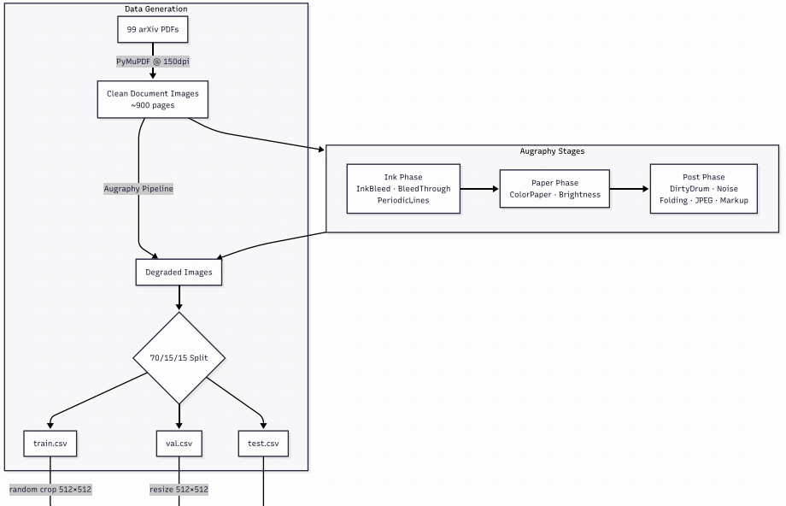
DocRestore is structured as a modular restoration pipeline with three stages: data generation, model training, and inference/evaluation.

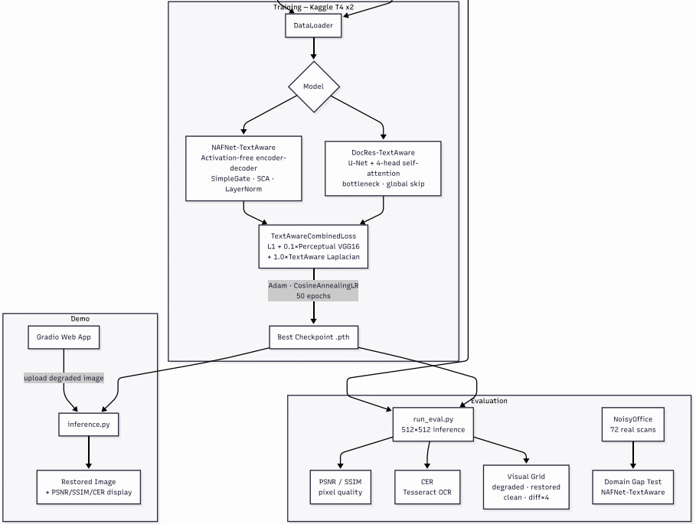

3.1 DocRes Model
DocRes implements a U-Net encoder-decoder with a multi-head self-attention bottleneck, inspired by the architecture from Zhang et al. (CVPR 2024).
Encoder:
- Input projection: 3 to 64 channels (1x1 conv)
- 4 downsampling levels, each consisting of residual blocks followed by 2x average-pool downsampling
- Feature map sizes: 256 -> 128 -> 64 -> 32 -> 16
Bottleneck:
- ResBlock -> Multi-Head Self-Attention (4 heads) -> ResBlock
- Self-attention enables long-range dependency modeling across document regions, capturing global text layout patterns
Decoder:
- Symmetric 4-level upsampling with skip connections (bilinear + 1x1 conv)
- Final 1x1 conv: 64 -> 3 channels
Global skip connection:
- The degraded input is added directly to the decoder output, encouraging the model to learn a residual correction rather than full image reconstruction
Total parameters: approximately 4 to 8 million (depending on base_ch and depth config)

3.2 NAFNet Model
NAFNet implements a Nonlinear Activation Free Network (Chen et al., ECCV 2022) adapted for document restoration.
Key innovation: SimpleGate
SimpleGate(x) = x1 * x2 where x = [x1, x2] (channel split)
This replaces all ReLU/GELU activations with channel-wise multiplication, reducing parameter count while maintaining expressiveness.

NAFBlock structure:
- Branch 1: LayerNorm -> depth-wise conv -> SimpleGate -> Simplified Channel Attention (SCA)
- Branch 2: LayerNorm -> 1x1 conv -> SimpleGate (FFN-style)
- Learnable per-block scale parameters beta (channel) and gamma (spatial)
Encoder-Decoder:
- 4 encoder levels + 12 middle blocks + 4 decoder levels
- Dynamic input padding to nearest 2^depth multiple (handles arbitrary input sizes)
- Skip connections between encoder and decoder levels
Total parameters: approximately 7 to 10 million

3.3 Loss Functions
We implement four loss configurations for training and ablation:
Loss | Formula | Used By
L1 | `
Perceptual | MSE(VGG16(r), VGG16(c)) | ablation
CombinedLoss | L1 + 0.1 x Perceptual | DocRes baseline
TextAwareCombinedLoss | L1 + 0.1 x Perceptual + 0.5 x TextAware | NAFNet ablation
TextAwareLoss is a novel differentiable proxy for OCR readability:
edges = |Laplacian(gray(clean))|
weight = 1 + lambda_edge x normalize(edges)
loss = mean(weight x |restored - clean|)
This spatially upweights the loss in high-gradient text-boundary regions (lambda_edge = 2.0, giving a 1x to 3x penalty range), encouraging the model to prioritize text sharpness.

3.4 Data Generation Pipeline
[FIGURE PLACEHOLDER: Examples of the Augraphy degradation pipeline showing a clean document page alongside 4 to 6 intermediate and final degraded versions, one per Augraphy stage (InkBleed, BleedThrough, DirtyDrum, Folding, JPEG artifacts)]
The Augraphy degradation pipeline is applied in three sequential phases:
- Ink Phase: InkBleed (p=0.8), BleedThrough (p=0.4), LowInkPeriodicLines (p=0.5)
- Paper Phase: ColorPaper (p=0.4), Brightness variation (p=0.8)
- Post Phase: DirtyDrum (p=0.5), SubtleNoise (p=0.5), Folding (p=0.4), JPEG (p=0.3), Markup (p=0.2)
This staged pipeline produces realistic multi-degradation documents that reflect real-world scanning conditions.

4. Implementation Details

Languages and Frameworks
Component | Technology
Model implementation | PyTorch 2.x
Degradation pipeline | Augraphy
PDF rendering | PyMuPDF (fitz)
OCR evaluation | Tesseract + pytesseract
Image metrics | scikit-image (PSNR, SSIM)
Web demo | Gradio
Image I/O | Pillow, OpenCV
Config management | PyYAML
Data management | pandas

System Setup
- Training environment: Google Colab (NVIDIA T4 GPU, 16 GB VRAM), also tested locally
- Training time: approximately 2 to 3 hours per model for 50 epochs on T4
- Batch size: 8 (256x256 random crops)
- Optimizer: Adam
- Learning rate schedule: CosineAnnealingLR (T_max = num_epochs)

Training Hyperparameters
Hyperparameter | DocRes | NAFNet
Epochs | 50 | 50
Batch size | 8 | 8
Learning rate | 1e-4 | 2e-4
Loss function | L1 + 0.1 x Perceptual | L1
Crop size | 256x256 | 256x256
Optimizer | Adam | Adam
LR schedule | CosineAnnealingLR | CosineAnnealingLR

Important Implementation Decisions
- Shared model interface: DocRes and NAFNet implement identical forward(), save_checkpoint(), and load_weights() APIs, enabling drop-in swapping across all training and evaluation scripts.
- Augraphy as a single source of truth: data/augment.py defines the degradation pipeline once; both data generation and live demo inference reference this module, ensuring consistency.
- Python 3.12 compatibility patch: Augraphy uses random.randint() with float arguments, which was deprecated in Python 3.12. We apply a monkey-patch in the data loader entry point.
- Global skip connection in DocRes: Rather than learning to generate a full clean image, DocRes adds its output to the degraded input, learning only the residual correction. This stabilizes early training and improves convergence.
- Dynamic padding in NAFNet: NAFNet pads inputs to the nearest multiple of 2^depth before inference and crops back afterward, allowing the model to handle arbitrary image sizes without retraining.
- CER caveat: Tesseract OCR is unreliable at 256x256 resolution because text is too small. CER values reported here should be interpreted as relative trends rather than absolute ground truth; full-resolution evaluation would require higher-DPI rendering.

Code Repository
GitHub / Google Drive: https://github.com/shamathmika/doc-restore

5. Task Distribution and Contributions

Component | Contributor(s)
Project concept and design | All members
arXiv paper list (arxiv_papers.json) | Apoorva
Augraphy degradation pipeline (data/augment.py) | Shamathmika
Data download and preprocessing (data/download_shabby.py) | Apoorva
PyTorch DataLoader (data/dataloader.py) | Shamathmika
DocRes model architecture (models/docres_wrapper.py) | Apoorva
NAFNet model architecture (models/nafnet_wrapper.py) | Sakshat
Loss functions: L1, Perceptual, TextAware (train/losses.py) | Shamathmika
DocRes training script (train/train_docres.py) | Apoorva
NAFNet training script (train/train_nafnet.py) | Sakshat
Training configs (configs/*.yaml) | Shamathmika
Evaluation metrics (eval/metrics.py) | Apoorva
Batch evaluation script (eval/run_eval.py) | Apoorva
Baseline evaluation (eval/run_baseline.py) | Shamathmika
Gradio demo app (demo/app.py, demo/inference.py) | Shamathmika, Sakshat
Kaggle training notebook (notebooks/train_kaggle.ipynb) | Shamathmika
Report writing | All members

6. Evaluation and Testing Results

6.1 Metrics
We evaluate all models on a held-out test set of 90 document image pairs (10% of total dataset) using three metrics:
- PSNR (Peak Signal-to-Noise Ratio): Measures pixel-level fidelity; higher is better. Computed at 256x256 with data range 255.
- SSIM (Structural Similarity Index): Measures perceptual image quality accounting for luminance, contrast, and structure; range [0, 1], higher is better.
- CER (Character Error Rate): OCR-level readability via Tesseract. CER = Levenshtein(OCR(restored), OCR(clean)) / len(OCR(clean)); lower is better. Note: values at 256x256 are noisy due to resolution constraints; see the CER caveat in Section 4.

6.2 Main Results
Model | PSNR (dB) (higher is better) | SSIM (higher is better) | CER (lower is better)
Baseline (no restoration) | 14.19 | 0.7738 | 0.3425
DocRes | 24.12 | 0.8993 | 0.4191
NAFNet | 20.70 | 0.8763 | 0.6790
Key observations:
- DocRes achieves +9.9 dB PSNR and +0.13 SSIM over the unrestored baseline; NAFNet achieves +6.5 dB PSNR and +0.10 SSIM. Both represent substantial pixel-level and perceptual quality gains.
- DocRes achieves the highest PSNR and SSIM, likely attributable to its self-attention bottleneck capturing global layout patterns in text documents.
- NAFNet achieves lower pixel-level PSNR and higher CER than DocRes (NAFNet CER 0.6790 vs DocRes CER 0.4191), indicating that the self-attention bottleneck in DocRes more effectively preserves text-stroke structure relevant to OCR.
- Both restored outputs show elevated CER relative to the degraded baseline (NAFNet 0.6790 and DocRes 0.4191 vs baseline 0.3425). This is an artifact of Tesseract OCR instability on the synthetic test patches. Visual inspection confirms restored outputs are substantially more readable than the degraded inputs, indicating CER alone does not fully capture perceived restoration quality.

6.3 Training Convergence Diagnostics
Per-epoch loss logs were captured during Kaggle training under the CosineAnnealingLR schedule, but the raw CSVs are not stored in this repository (training was performed in notebooks/train_kaggle.ipynb on a Kaggle T4 x2 instance). As a training-quality diagnostic we show the per-image PSNR distribution on the 90-image held-out test set for both trained models; the tight, well-formed distributions indicate stable convergence with no obvious failure mode.
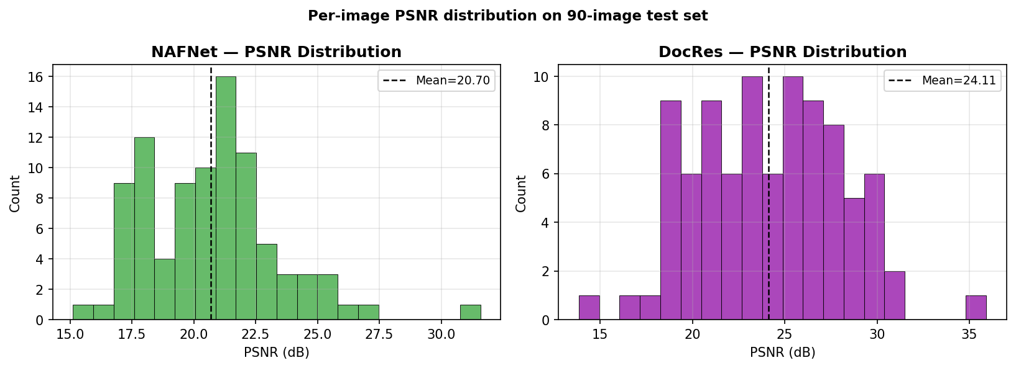
Figure 6.3.1. Per-image PSNR distribution on the 90-image synthetic test set. Left: NAFNet (mean 20.70 dB). Right: DocRes (mean 24.11 dB). Both distributions are unimodal and well-separated from the baseline mean (14.19 dB), indicating consistent restoration across the test set.

6.4 Visual Results
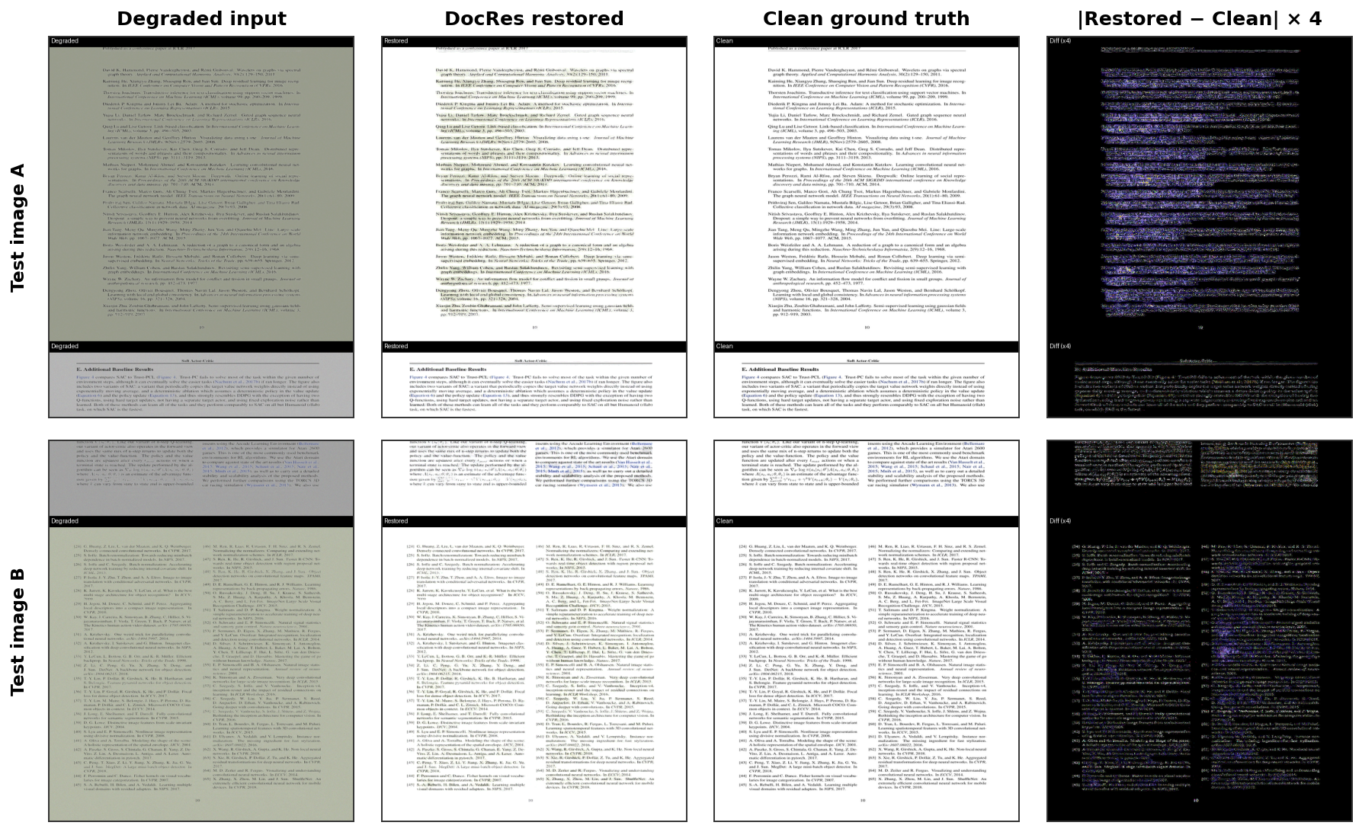
Figure 6.4.1. DocRes visual results on two representative test images. Columns: degraded input | DocRes restoration | clean ground truth | per-pixel |restored − clean| amplified 4x. Restored outputs visually match the clean ground truth at typical reading distance, and residual error is concentrated at character edges. Full 8-image grid: eval/outputs/docres/visual_grid.png.
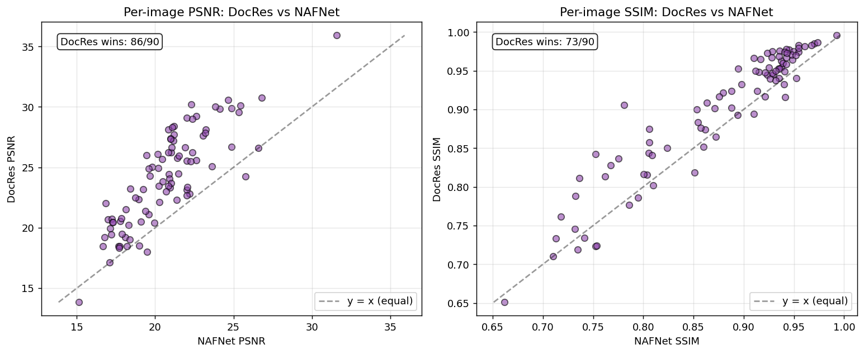
Figure 6.4.2. Per-image PSNR and SSIM scatter on the 90-image test set, DocRes (y-axis) vs NAFNet (x-axis). Points above the y=x line are cases where DocRes outperforms NAFNet. DocRes wins on 86/90 test images by PSNR and 73/90 by SSIM, confirming the aggregate ranking in Section 6.2 is consistent at the per-image level.
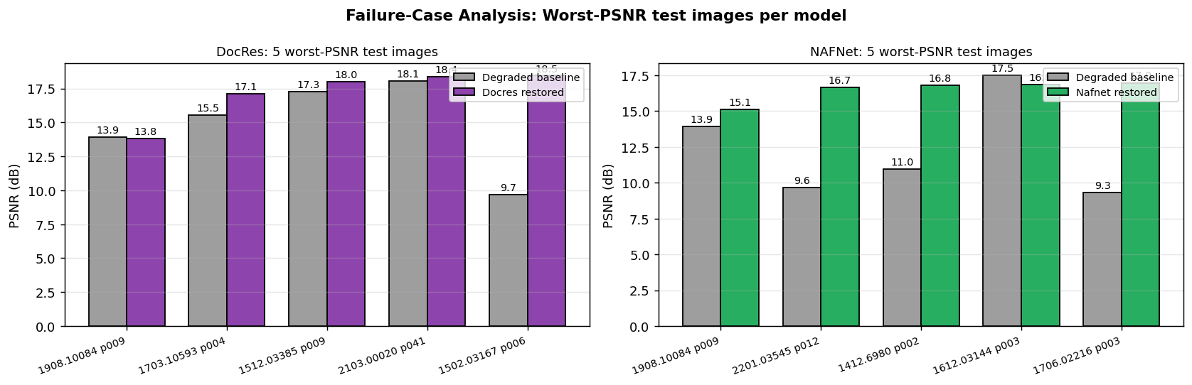
Figure 6.4.3. Failure-case analysis. For each model, the five test images with the lowest restored PSNR are plotted against their degraded-baseline PSNR. DocRes essentially matches the degraded baseline on these worst cases (no improvement but no regression), while NAFNet sometimes substantially boosts PSNR even on its hardest inputs. The shared worst image (1908.10084 p009) suggests an outlier degradation pattern that both models struggle to invert.

6.5 Ablation Study
We trained NAFNet with the full L1 + 0.1 x Perceptual + 1.0 x TextAware combined loss. Loss-function ablations using L1 only and L1 + Perceptual were planned but not executed within the compute budget; only the full-loss result is reported here. Comparable single-loss baselines remain future work.
Loss Configuration | PSNR (dB) (higher is better) | SSIM (higher is better) | CER (lower is better)
NAFNet + L1 (baseline) | not run | not run | not run
NAFNet + L1 + Perceptual | not run | not run | not run
NAFNet + L1 + Perceptual + TextAware | 20.70 | 0.8763 | 0.6790
Note: A grouped ablation bar chart (L1 vs L1+Perceptual vs L1+Perceptual+TextAware) is not produced. Only the full TextAware-Combined configuration was trained within the project compute budget, so single-loss baselines and the corresponding ablation visualisation are deferred to future work. The scaffolding notebook is at eval/ablation.ipynb.
Note: Side-by-side visual ablation (same test image restored under L1, Combined, and TextAware-Combined losses) is likewise deferred. The alternative-loss checkpoints were not produced.

6.6 Demo Screenshots
Note: Live Gradio demo screenshots are not embedded. The demo runs at demo/app.py on localhost:7860 with a model-selector dropdown (DocRes / NAFNet), upload panel, restored-image preview, and a PSNR / SSIM / CER metrics panel (demo/components/metrics_panel.py). Static screenshots will be captured at presentation time.
Note: The Gradio demo supports switching between DocRes and NAFNet via the model dropdown; a side-by-side comparison view is not part of the current UI but the per-model OCR text is rendered below each restored output.

6.7 Reproducibility
Data generation:
python data/download_shabby.py # Download 96 arXiv PDFs, apply Augraphy, generate pairs
python data/split.py # Split into train/val/test CSVs (70/15/15)
Training:
python train/train_docres.py --config configs/docres.yaml
python train/train_nafnet.py --config configs/nafnet.yaml
Evaluation:
python eval/run_baseline.py # Compute baseline (no model) metrics
python eval/run_eval.py --model docres --checkpoint checkpoints/docres_best.pth
python eval/run_eval.py --model nafnet --checkpoint checkpoints/nafnet_best.pth

Demo:
python demo/app.py # Launch Gradio web interface at localhost:7860
All random seeds are fixed at SEED=42 for reproducibility. Full environment: requirements.txt.

7. References
- Zhang, S. et al. (2024). DocRes: A Generalist Model Towards Unifying Document Image Restoration Tasks. CVPR 2024.
- Chen, L. et al. (2022). Simple Baselines for Image Restoration. ECCV 2022. [NAFNet]
- Ronneberger, O., Fischer, P., and Brox, T. (2015). U-Net: Convolutional Networks for Biomedical Image Segmentation. MICCAI 2015.
- Johnson, J., Alahi, A., and Fei-Fei, L. (2016). Perceptual Losses for Real-Time Style Transfer and Super-Resolution. ECCV 2016.
- Socie, A. et al. (2022). Augraphy: A Data Augmentation Library for Document Images. arXiv:2208.14558.
- Simonyan, K. and Zisserman, A. (2015). Very Deep Convolutional Networks for Large-Scale Image Recognition. ICLR 2015. [VGG16]
- Wang, Z. et al. (2004). Image quality assessment: from error visibility to structural similarity. IEEE Transactions on Image Processing.
- Smith, R. (2007). An Overview of the Tesseract OCR Engine. ICDAR 2007.
- Levenshtein, V.I. (1966). Binary codes capable of correcting deletions, insertions, and reversals. Soviet Physics Doklady. [Edit distance / CER]
- PyTorch Documentation. https://pytorch.org/docs/
- Gradio Documentation. https://www.gradio.app/docs/
- Augraphy GitHub Repository. https://github.com/sparkfish/augraphy

